**Statistics: The Science of Decisions Project Instructions**

**Background Information**

In a Stroop task, participants are presented with a list of words, with each word displayed in a color of ink. The participant’s task is to say out loud the *color of the ink* in which the word is printed. The task has two conditions: a congruent words condition, and an incongruent words condition. In the *congruent words* condition, the words being displayed are color words whose names match the colors in which they are printed: for example RED, BLUE. In the *incongruent words* condition, the words displayed are color words whose names do not match the colors in which they are printed: for example PURPLE, ORANGE. In each case, we measure the time it takes to name the ink colors in equally-sized lists. Each participant will go through and record a time from each condition.

**Questions For Investigation**

As a general note, be sure to keep a record of any resources that you use or refer to in the creation of your project. You will need to report your sources as part of the project submission.

1. What is our independent variable? What is our dependent variable?
2. The independent variable is the whether the condition is congruent or incongruent. The dependent variable is the time required to name the color in each condition.
3. What is an appropriate set of hypotheses for this task? What kind of statistical test do you expect to perform? Justify your choices.

$H_{0}:The time required to identify the color in incongruent condition is equal to that in the$

$$congruent condition.$$

$H_{A}:The time required to identify the color in incongruent condition is different than that in the$

$$congruent condition.$$

This hypothesis is appropriate as we need to check whether the statement made in the alternate hypothesis – the Stroop effect - is true or not.

We expect to perform a two-sided paired t-test. This is because we don’t know the mean population times for identification of the colors in incongruent and congruent conditions. Also, it is a paired t-test as the same subject is asked to identify the color of the ink in congruent and incongruent conditions.

Now it’s your chance to try out the Stroop task for yourself. Go to [this link](https://www.google.com/url?q=https%3A%2F%2Ffaculty.washington.edu%2Fchudler%2Fjava%2Fready.html&sa=D&sntz=1&usg=AFQjCNGc_1cOHZy4iwBhM93xXvCImuQ1sQ), which has a Java-based applet for performing the Stroop task. Record the times that you received on the task (you do not need to submit your times to the site.) Now, download [this dataset](https://drive.google.com/file/d/0B9Yf01UaIbUgQXpYb2NhZ29yX1U/view?usp=sharing) which contains results from a number of participants in the task. Each row of the dataset contains the performance for one participant, with the first number their results on the congruent task and the second number their performance on the incongruent task.

1. Report some descriptive statistics regarding this dataset. Include at least one measure of central tendency and at least one measure of variability.
2. For the congruent condition, the mean and the variance of times measured are 14.05 and 3.56 respectively. For the incongruent condition, the mean and the variance of times measured are 22.06 and 4.8 respectively.
3. Provide one or two visualizations that show the distribution of the sample data. Write one or two sentences noting what you observe about the plot or plots.
4. 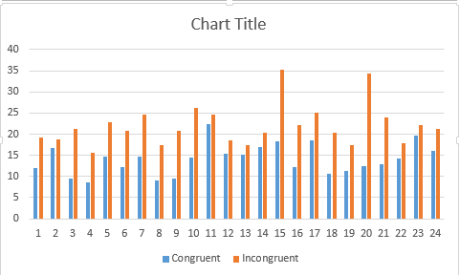

The above chart shows that the time required to name a color in incongruent condition is always more than that in congruent condition.

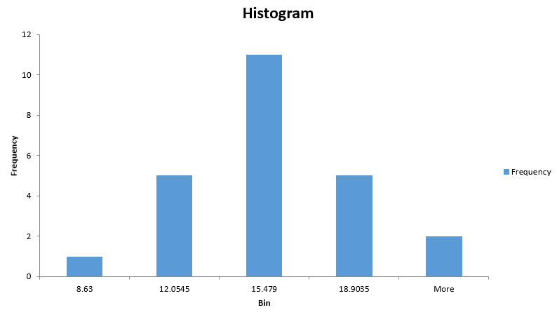

The above chart is the histogram of the time required to identify color in incongruent condition.

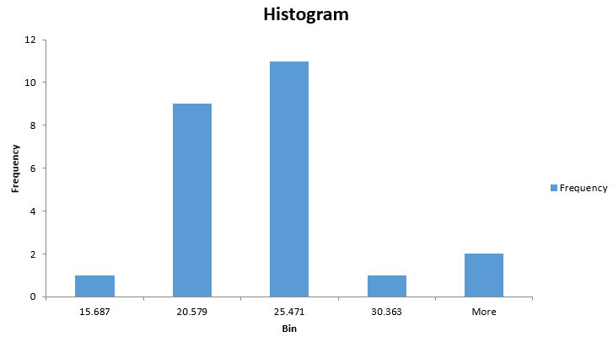

The above chart is the histogram of the time required to identify color in congruent condition.

1. Now, perform the statistical test and report your results. What is your confidence level and your critical statistic value? Do you reject the null hypothesis or fail to reject it? Come to a conclusion in terms of the experiment task. Did the results match up with your expectations?

$$H_{0}: μ_{congruent}= μ_{incongruent}$$

$$H_{A}: μ_{congruent}≠ μ_{incongruent}$$

$$t_{critical}=2.069 for 23 degrees of freedom at level of confidence α=0.05$$

$$s_{D}=4.86$$

$$t=\frac{μ_{D}}{{s_{D}}/{\sqrt{n}}}=\frac{7.96}{{4.86}/{\sqrt{24}}}=8.02$$

Since ${t>t}_{critical}$, we reject the null hypothesis.

Hence, the time required to identify the color in congruent and incongruent conditions are not equal.